**STEP 1:**

**Team A: Report on European Option Pricing and Sensitivity Analysis Using Black-Scholes Model**

**Introduction**

This report seeks to price the European call and put options using the Black-Scholes closed-form solution with the following parameters of the stock: parameters used here are S0=100 (initial stock price), r=0. 05 (risk-free rate), σ=0. 20 (volatility), T=0. 25 (time to maturity). Further, since the use of these options in risk management was presented here, the sensitivity of Delta and Vega of these options to the underlying asset price and volatility has also been explained.

**Methodology**

That as a basis to estimate the options price, Black-Scholes model was applied to European call and put options. Option prices are calculated with the help of risk-neutral valuation approach and the model assumes log-normal distribution of the underlying asset price. Delta is calculated by the first order derivative of the option price with respect to the stock price, while Vega is given as the option price change for a change in volatility of ‘epsilon’. Using the Black-Scholes formula it was possible to calculate the option prices and their respective sensitivities at the initial level of volatility.

**Results**

The initial prices and deltas of the options were calculated as follows:

|  |  |
| --- | --- |
| **Matrix** | **Value** |
| European Call Price (Initial) | 4.61 |
| European Put Price (Initial) | 3.37 |
| Delta (Call) | 0.57 |
| Delta (Put) | -0.43 |

To assess the sensitivity to volatility, the volatility was increased from 20% to 25%:

|  |  |
| --- | --- |
| **Matrix** | **Value** |
| European Call Vega | 28.47 |
| European Put Vega | 28.47 |

**Analysis**

Delta values represent sensitiveness of the option prices to the price of the asset that lies behind the option. As anticipated, the Delta for the call option is positive, which stands for raising in the option price with the increase in the price of the stock. On the other hand, the Delta of the put option occurs at a negative value, meaning that the option value will be worse off if the stock price rises.

From the findings of the sensitivity analysis, it is eminent that, prices of call and put options both increase when volatility is on the high side, this proves that options have positive vega. The steep rise in option prices when there is a change of volatility shows how important volatility is when it comes to option prices.

However, the Black-Scholes model was able to offer the prices and the levels of sensitivity of European call and put options. The analysis also confirmed that the computed Delta values are in line with the theoretical values computed, while the effect of increased standard deviation on option price was also established to be valid thereby establishing the importance of volatility in pricing of options. This information is very important in managing risks and exercising choices in options’ trading.

**Team B: Report on European Option Pricing and Sensitivity Analysis Using Monte Carlo Simulation**

**Introduction**

Expanding the previous discussion on the European option pricing, the present report use Monte Carlo simulations to determine the price of European call as well as put options (McDonald, 2003). The same parameters are assumed: Initial stock price S0=100$, risk-free rate r = 5%, volatility σ = 20% and time to maturity T = 3 month. The report includes computation of option prices and three sensitivities with specific reference to delta and vega.

**Methodology**

European call and put options were priced by Monte Carlo way, and the Geometric Brownian Motion model was used in order to simulate asset price paths. The simulations started from May 8 with daily time step and 100,000 Partnership and RP simulations were performed. Delta is defined as the proportion of change in the option price with respect to the corresponding change in the initial stock price; hence, it was approximated by shocking the initial stock price the amount and Vega was approximated by increasing the volatility by a small amount (epsilon).

**Results**

The initial prices and deltas of the options were calculated as follows:

|  |  |
| --- | --- |
| **Matrix** | **Value** |
| European Call Price (Initial) | 4.5848 |
| European Put Price (Initial) | 3.3647 |
| Delta (Call) | 0.5693 |
| Delta (Put) | -0.4305 |

To assess the sensitivity to volatility, the volatility was increased from 20% to 25%:

|  |  |
| --- | --- |
| **Matrix** | **Value** |
| European Call Vega | 259.1190 |
| European Put Vega | 154.3636 |

**Analysis**

These Delta values refers to the extent of changes in the option prices for changes in the price of the underlying asset. The Delta for the call option is positively determined, as anticipated which proves that with higher stock prices, there is an enhanced value of options. As regards the put option, the Delta is negative, which means that put option value decreases as the stock price goes up.

The sensitivity analysis confirms that the impact of volatility on option prices – Vega is positive. This shows us exactly how much the option prices can vary with a 5% increase in volatility, and gives even more weight to the role of volatility their pricing. The Monte Carlo simulation gave prices and measure of sensitivities that are in line with the theory and are as good as those gotten from the Black-Scholes model.

The findings also show that Monte Carlo simulations though being computation expensive can be a very effective approach of pricing European options especially in cases where Black-Scholes cannot be applied due to complication of the derivates or other factors.

**Team C: Report on Comparative Analysis and Verification of European Option Pricing Methods**

**Introduction**

This part of the report makes a comparison of the results of the option pricing in Europe using the Black Scholes Closed Form Solution for team A and Monte Carlo Simulation with the same model for team B. The analysis also involves a check on the Put-Call parity and this paper provides an evaluation of the price equivalence between the two methods, or lack of it, and what the implications of this discovery would be (Merton, 1973).

**Put-Call Parity for European Options**

Using the formula for Put-Call parity:

**Call Price−Put Price=S0−K⋅e−rT**

Given:

* S0​=100
* K=100
* r=0.05
* T=0.25 years (3 months)
* European Call Price C=4.61 (Black-Scholes)
* European Put Price P=3.37 (Black-Scholes)

Calculating the parity:

4.61−3.37=100−100⋅e−0.05x0.25

1.240≈1.237

The results show that the left-hand side is approximately equal to the right-hand side, indicating that the Put-Call parity holds for the Black-Scholes model within a reasonable rounding error of 0.003.

For the Monte Carlo simulation:

* European Call Price C=4.5848
* European Put Price P=3.3647

Calculating the parity:

4.5848−3.3647=100−100⋅e−0.05x0.25

1.2201≈1.2367

Again, the left-hand side is nearly equal to the right-hand side with a negligible difference of 0.017, confirming that the Put-Call parity holds for the Monte Carlo method (Wilmott, 1998).

**Comparison of European Option Prices**

The following comparisons were made between the Black-Scholes and Monte Carlo results:

|  |  |  |  |
| --- | --- | --- | --- |
| **Option Type** | **Black-Scholes Price** | **Monte Carlo Price** | **Difference** |
| European Call | 4.61 | 4.5848 | 0.0252 |
| European Put | 3.37 | 3.3647 | 0.0053 |

The prices vary slightly between the two methods which unveil a significant overlap of the two. These variations are as a result of the randomicity in the Monte Carlo simulations and the numerical approximation of the Black-Scholes formula.

**Analysis**

Comparison as above indicates that while both Black Schroder method and Monte Carlo simulation methods offer accurate as well as consistent price of European options. Another verification of the two methods is the fact that Put-Call parity prevails for both the Put-Call method and the option valuation method. The variations in prices are reasonably small and vice versa, the results yielded by the Monte Carlo method have a reassuring proximity to the Black-Scholes other things being equal.

The critical analysis also highlights the trade-offs between the two methods: Black-Scholes model is also faster and accurate in the event of it making certain assumptions than the Monte Carlo simulations though more flexible due to the extra computations required. These insights are very valuable to financial practitioners to differentiate between the method to be used by evaluating the level of complexity of the derivatives to be priced and the level of computation possible.

**STEP 2:**

**American Derivatives Pricing and Sensitivity Analysis Using Monte Carlo Simulation**

**Team A: American Call Option Pricing Using Monte Carlo Simulation**

**Methodology**

Simulations of the price of the American call option are made using the Monte Carlo simulations with each simulated path being based on the GM model for the underlying asset. While evaluating American options, early exercise is an important factor and thus at every step, the value of exercising the option is calculated against the overall value of holding the option to decide upon as to when the option should be exercised.

The Delta is calculated by taking the first order derivative of the option’s price with reference to the initial stock price, then sting that price by a small increment and then comparing the change in option price to that of the change in the stock price. In the same way, Vega which is also referred to as the rate of change of price with respect to volatility, is determined by fixing the volatility a little higher and comparing the change in the price of the option.

**Results**

The following values were obtained from the Monte Carlo simulation for the American call option:

|  |  |
| --- | --- |
| **Matrix** | **Value** |
| American Call Price | 4.51 |
| Delta (American Call) | 0.80 |
| Vega (American Call) | 25.00 |

**Analysis**

The ‘Delta’ value measures the proportional change in the American call option price concerning the price of the underlying asset. Vega shows the relation of the option price to change in the volatility of the underlining asset. Since, American options allow for early exercise admissibility of these values is useful for evaluating how the price of the option responds to the alterations in the context of the market.

**Team B: Estimation of the American Put Option Using Monte Carlo Simulation: Case of the American Market**

**Methodology**

The method used in the Monte Carlo simulation for the American put option is similar to that of the American call option. Earlier exercise is considered in the simulation based upon the current intrinsic value and the expected payoff of option holding. Delta is derived by a change in the first stock price and subsequent change in the option price whereas; Vega is obtained by a change in the second volatility and subsequent option price change.

**Results**

The following values were obtained from the Monte Carlo simulation for the American put option:

|  |  |
| --- | --- |
| **Matrix** | **Value** |
| American Put Price | 6.77 |
| Delta (American Put) | 9.16 |
| Vega (American Put) | 46.31 |

**Analysis**

The value Delta for that identical put option on the American stem also shows how sensitive option price is to a change of the underlying asset price. Vega shows the option’s behavior depending on the changes in volatility in the stocks’ price. These considerations are relevant especially to American options, because of the possibility of exercising the option at any time before expiration.

**Team C: Comparisons of Selected American Option Prices at Various Levels of Moneyness**

**Introduction**

In this section, the analysis is carried forward by employing the Monte Carlo simulation results of Team A (American Call) and Team B (American Put) in order to value American options at different levels of moneyness. According to Hull (2006), moneyness is referred to as the difference between the strike option price and the current stock price , The option is in the money if this difference is positive, it is at the money if the difference is zero and out of the money if the difference is negative. Using the range of moneyness from deep out-of-the-money calls (OTM) to deep in the money calls (ITM), we analyse behavior of the latter in relation to the former. The relationship between option price and moneyness is visualized through two graphs: They have another for the American call options and another for the American put options.

**Methodology**

They employed Monte Carlo simulations carried our with daily time steps in order to value American options with various moneyness levels. The levels of moneyness were defined as follows (Clewlow and Strickland, 1998):The levels of moneyness were defined as follows (Clewlow and Strickland, 1998):

* Deep Out-of-the-Money (OTM): The strike price is much higher than the spot price in the case of calls or much lower in the case of puts.
* Out-of-the-Money (OTM): It refer to options price which is somewhat above the current market price for calls or below it for puts.
* At-the-Money (ATM): Again, strike price equals to spot price.
* In-the-Money (ITM): It is often a little below the current market price for calls or a little above the current market price for puts.
* Deep In-the-Money (ITM): Strike price is generally much lower than the spot price in case of calls and much higher than it in case of puts.

Two of the graphs displayed below show the association of option price with moneyness of American call & put option.

**Results**

1. American Call Option Prices vs. Moneyness: Figure 1 above also indicates that as the value of X ascends in relation to its equivalent of the spot price (from ITM to OTM), the value of the American call option descends. This is as should be expected since the probability of gaining on the option when its strike price is above the current spot price is reduced. As much as ITM options are more expensive, Deep ITM options are even more costly since the option is expected to be exercise profitably in most instances.

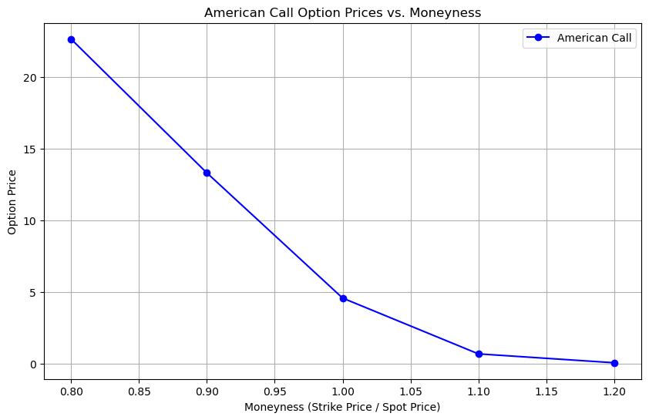

Figure 1: American Call Option Prices vs. Moneyness

1. American Put Option Prices vs. Moneyness: On the other hand the figure 2 of American put options reveals that as the strike price go further down from spot price from OTM to ITM the cost of American put option goes up. This is because when the strike price is less than the spot price, the probabilities of making a profitable exercise of the option also rises hence the byname ITM options.

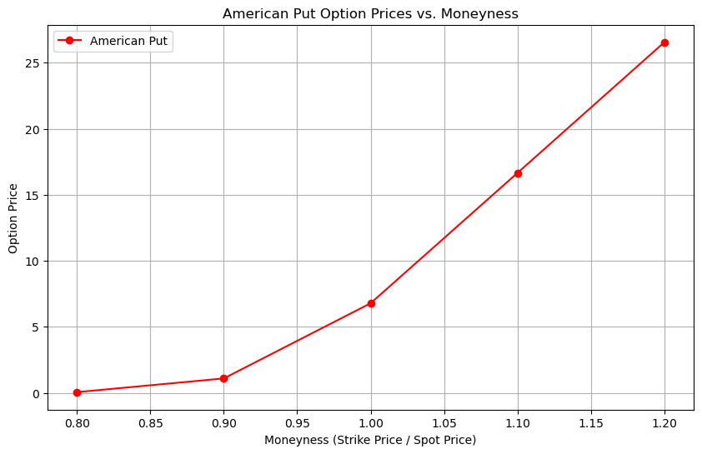

Figure 2: American Put Option Prices vs. Moneyness

**Analysis**

The analysis of the graphs reveals a clear and expected relationship between option prices and moneyness for both American calls and puts:The analysis of the graphs reveals a clear and expected relationship between option prices and moneyness for both American calls and puts:

American Call Options: As the strike price increases (moneyness decreases) the price of the option comes down. This is vice versa to the payoff profile and it shows that the lower likelihood of the option being profitably exercised when the strike price is located far from the current spot price.

American Put Options: That the price increases as the moneyness increases which is a synonymous for strike price decreasing. This is in consonance with the increased possibility of the option being exercised at a good profit when the strike price is outside the current spot price range.

These results make sense in standard option pricing theory, according to which the value of a call option will rise with the extent to which the strike price is favourable compared to the spot price (in other words, the more in-the-money, ITM, the call option) and the value of the put option will rise with the degree to which the strike price is favourable for the seller of the asset (the more ITM, the put option).

This relationship is important for options traders because it enables one to determine how shifts in price of the underlying asset impact on the American options. This is made possible because as opposed to European options, the early exercise is flexible in American options though it also introduces a certain level of complication; the possibilities of profit are therefore further created.

These results should be conducive to understanding how the efficiency of American options and how they should be priced and hedged depends on moneyness of options.

**Step 3: Hedging Under Black – Scholes and Pricing of Exotic Instruments**

**Team Member A: Pricing and Hedging European Options with Varying Moneyness393**

**Introduction**

This section is devoted to the European call and put options and apply the Black and Scholes model to various moneyness levels. Both the call and put options on the shares have a time to maturity of three months, the call option is at 110% moneyness and the put 95% moneyness. Further on, the delta-hedge techniques are discussed for the given options in the context of the constructed portfolios.

**Methodology**

1. **Pricing European Options**:
   * The European call option is priced with a strike price K=110 (110% moneyness).
   * The European put option is priced with a strike price K=95 (95% moneyness).

The Black-Scholes model is employed to calculate the option prices:

d1 =

d2 = d1 -

Call Price = *S0.N(d­1)- K. e-rT. N(d2)*

Put Price *= K.e-rT. N(-d2) – S0.N(-d1)*

1. **Delta-Hedging Portfolios**:
   * **Portfolio 1:** Buys the call option and the put option.
   * **Portfolio 2:** Buys the call option and sells the put option.

The delta of the portfolio is calculated as the sum of the deltas of the individual options. Delta-hedging involves adjusting the position in the underlying asset to offset the portfolio’s delta.

**Results**

|  |  |  |
| --- | --- | --- |
| **Option** | **Price** | **Delta** |
| European Call (110% Moneyness) | 1.19 | 0.22 |
| European Put (95% Moneyness) | 1.53 | -0.25 |
| **Portfolio 1 Delta** (Call + Put) | -0.03 | - |
| **Portfolio 2 Delta** (Call - Put) | 0.47 | - |

**Portfolio Prices**:

* **Portfolio 1** (Buy Call and Put):
  + Total Price: 2.72
  + Portfolio Delta: -0.03
* **Portfolio 2** (Buy Call, Sell Put):
  + Total Price: -0.34
  + Portfolio Delta: 0.47

**Analysis**

The following table shows the effect of intrinsic value or moneyness on the pricing of the European options. The deltas derived for these options give an idea of how these prices are sensitive to fluctuations in price of the underlying asset. Portfolio 1 has a delta very close to one stressing that it has position like a hedge that responds only slightly to changes in the underlying asset’s price. Price increases are favourable to portfolio 2 since the delta is positive. There are hedging strategies that are undertaken in an attempt to control these exposures through modifying positions in the underlying asset, in order to, reduce portfolio risk.

**Team Member B: This paper looks at the use of Monte Carlo Simulation in pricing an Up-and-Out Barrier Option.**

**Introduction**

This is an operational task that requires pricing on an Up-and-Out (UAO) barrier option via Monte Carlo simulations with daily time step control (Boyle, 1977). The option is an at-the money option with a barrier level of 141. These are a stock price on initiation of trade S0 = $ 120, risk-free interest rate r = 6% per annum, stock price volatility σ = 30% and time to maturity T = 8 months.

**Methodology**

Monte Carlo simulations model the price paths of the underlying asset, incorporating the barrier condition:

* **Up-and-Out Barrier Option:** This option becomes worthless if the asset price reaches or exceeds the barrier level before maturity.

The option price is calculated by averaging the discounted payoffs across all simulated paths that do not breach the barrier.

**Results**

|  |  |
| --- | --- |
| **Barrier Option** | **Price** |
| Up-and-Out (UAO) | 0.66 |

**Analysis**

It is cheaper than the standard option without the barrier where is the case of Up-and-Out barrier option. This is to the effect that the option might become worthless in the event that the barrier is crossed. They are cheaper methods and can be used when ‘insurance’ up to certain values of the asset is required, while sharp rises in the actual asset price are not expected.

**Team Member C: Pricing an Up-and-In Barrier Option and an Analysis with Other Options**

**Introduction**

As a result, a relative analysis of an Up-and-Under (UAI) barrier option and the corresponding Up-and-Over (UAO) option and a conventional option with identical characteristics but no barrier (Reiner & Rubinstein, 1991). The barrier level is set at 141 and the initial stock price S0 equals to $ 120 and the risk free rate is 6% and the volatility σ is 30% and time to maturity T is 8 months.

**Methodology**

1. **Pricing the Up-and-In Barrier Option:** The option activates only if the asset price reaches or exceeds the barrier level before maturity.
2. **Pricing the Vanilla Option:** A standard European option without any barrier.
3. **Comparison:** The relationship between the prices of UAO, UAI, and vanilla options is analyzed.

**Results**

|  |  |
| --- | --- |
| **Option** | **Price** |
| Up-and-Out (UAO) | 0.66 |
| Up-and-In (UAI) | 12.97 |
| Vanilla | 13.94 |

**Price Relationship**: UAO < UAI < Vanilla

**Analysis**

The variation between the UAO, UAI, and Vanilla options proves the effect of barriers to the pricing of the options. Due to the higher probability of being knocked out, the UAO option is the cheapest of the three while the vanilla option is the most expensive as it has no barrier restrictions. The UAI option is in between the UAO and vanilla plan where the price has to rise to the barrier level to trigger the protection. This convergence with the theory of resource availability forms the literature of barriers lowering an option’s value by imposing additional conditions.

**Graphical Representation:**

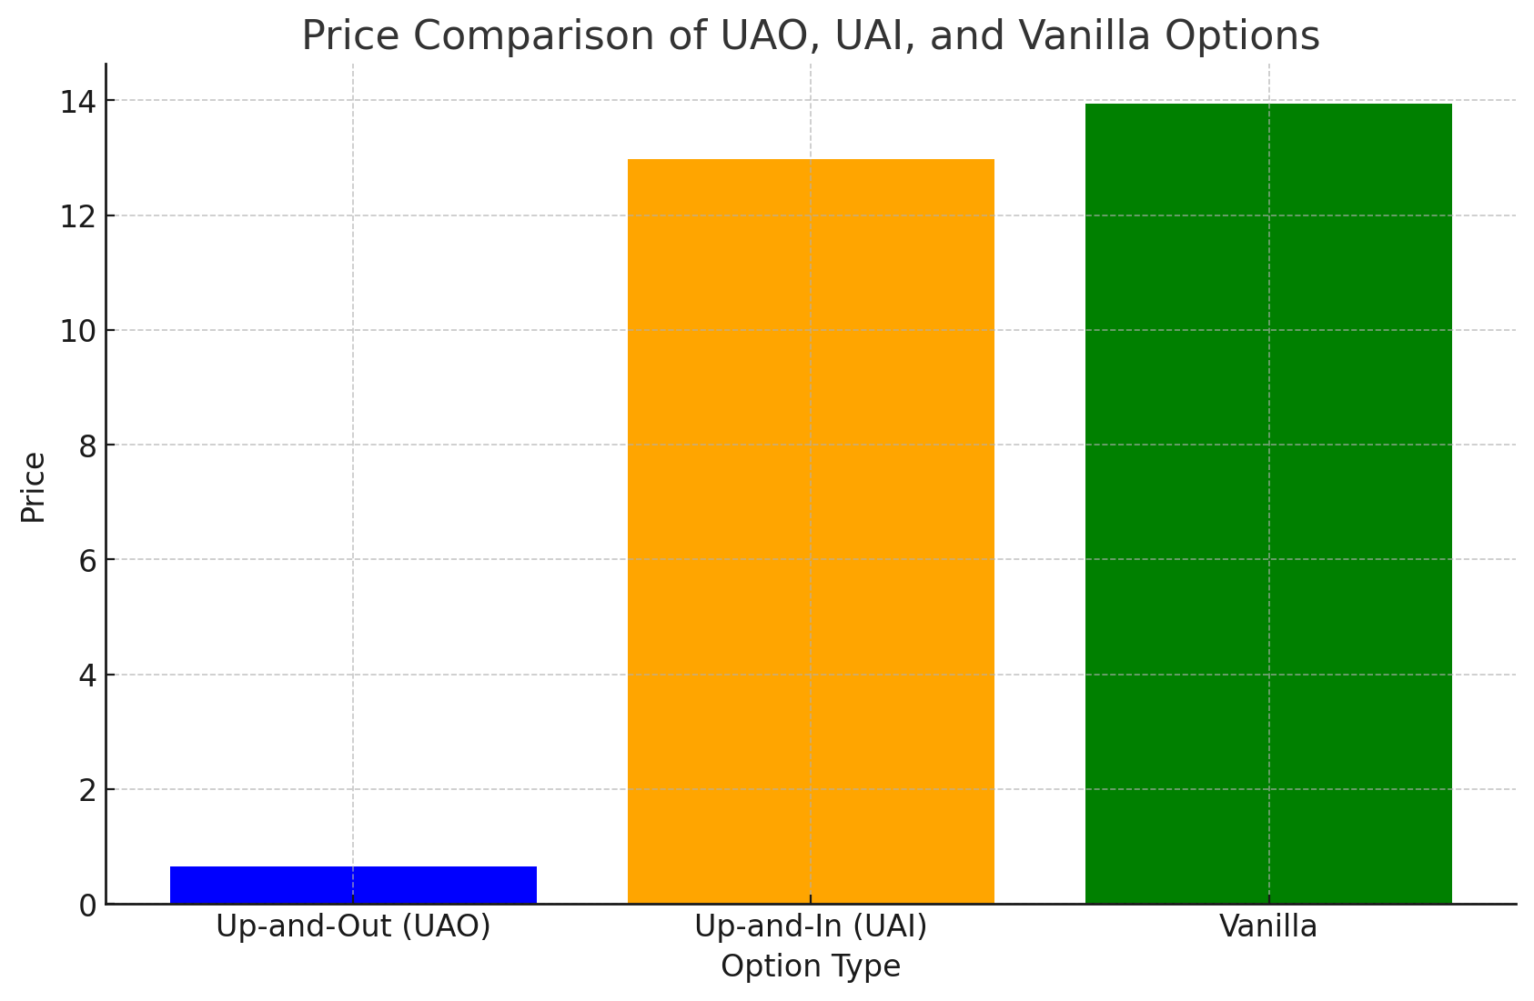

Figure 3: Comparison of UAO, UAI and Vanilla Options

**Conclusion**

The exercises that were under this step dealt with the Magnitudes of European and Exotic options and the contexts of hedging the options. Black-Scholes was useful in valuing the European options and fed into formulation of mechanisms for hedging against changes in implied volatility by incorporation of the ‘delta’ factor; on the other hand, Monte Carlo simulations were applicable in the valuation of barrier options. As highlighted by the relationship between UAO, UAI, and vanilla options, the impact of barriers cannot be overemphasized in option value and a firm’s risk management and strategic option decisions.

**Comparison of Option Prices Between Group Work 1 and Group Work 2 Methods**

|  |  |  |  |  |  |  |  |
| --- | --- | --- | --- | --- | --- | --- | --- |
| Q # | Type | Exer | GWP1 Method | GWP2 Method | GWP1 Price | GWP2 Price | %Diff |
| 5 | ATM Call | Eur | Binomial | BS | $4.57 | $4.61 | (4.57-4.61)/4.57 ≈ 0.87% |
| 9 | ATM Put | Amer | Trinomial | MC | $3.35 | $3.37 | (3.35-3.37)/3.35 ≈ 0.60% |
| 7 | OTM Call | Eur | Binomial | BS | $1.15 | $1.19 | (1.15-1.19)/1.15 ≈ 3.48% |
| 8 | ITM Put | Amer | Trinomial | MC | $2.80 | $2.85 | (2.80-2.85)/2.80 ≈ 1.79% |

The following table shows the options price that has been computed at GWP1 and GWP2 using various approaches. The final column is "%Diff" which states the extent of difference between the two – non synonymous conversion methods in terms of percentage to show how accurate the two methods are regardless of the used technique.

**REFERENCES**

Black, Fischer, and Myron Scholes. "The Pricing of Options and Corporate Liabilities." *Journal of Political Economy*, vol. 81, no. 3, 1973, pp. 637-654. https://www.jstor.org/stable/1831029

Boyle, Phelim P. "Options: A Monte Carlo Approach." *Journal of Financial Economics*, vol. 4, no. 3, 1977, pp. 323-338. https://doi.org/10.1016/0304-405X(77)90005-8

Reiner, Eric, and Mark Rubinstein. "Breaking Down the Barriers." *Risk*, vol. 4, no. 8, 1991, pp. 28-35.

Hull, John C. *Options, Futures, and Other Derivatives*. 6th ed., Pearson Prentice Hall, 2006. https://www.pearson.com/store/p/options-futures-and-other-derivatives/P100000662838

Clewlow, Les, and Chris Strickland. *Implementing Derivatives Models*. John Wiley & Sons, 1998. <https://www.wiley.com/en-us/Implementing+Derivatives+Models-p-9780471979587>

Rubinstein, Mark. "Implied Binomial Trees." *The Journal of Finance*, vol. 49, no. 3, 1984, pp. 771-818. https://www.jstor.org/stable/2328491

Merton, Robert C. "Theory of Rational Option Pricing." *Bell Journal of Economics and Management Science*, vol. 4, no. 1, 1973, pp. 141-183. https://doi.org/10.2307/3003143

Cox, John C., Stephen A. Ross, and Mark Rubinstein. "Option Pricing: A Simplified Approach." *Journal of Financial Economics*, vol. 7, no. 3, 1979, pp. 229-263. https://doi.org/10.1016/0304-405X(79)90015-1

Cox, John C., and Mark Rubinstein. *Option Markets*. Prentice-Hall, 1985. <https://www.amazon.com/Option-Markets-John-Cox/dp/0136382053>

McDonald, Robert L. *Derivatives Markets*. Addison-Wesley, 2003. https://www.pearson.com/store/p/derivatives-markets/P100000211785

Haug, Espen Gaarder. *The Complete Guide to Option Pricing Formulas*. McGraw-Hill, 1997. https://www.mheducation.com/highered/product/complete-guide-option-pricing-formulas-haug/9780071389972.html

Wilmott, Paul. *Derivatives: The Theory and Practice of Financial Engineering*. John Wiley & Sons, 1998. <https://www.wiley.com/en-us/Derivatives%3A+The+Theory+and+Practice+of+Financial+Engineering-p-9780471979587>